Clean Air Means Better Indoor Air Quality And A Safer Home And Family

According to the EPA (Environmental Protection Agency), the air quality inside your home can be up to 5 times more polluted than the air outside it! With that said, it isn’t IF you need an air filtration system but rather what kind should you get.

Improvements in Home Indoor Air Quality technology have occurred rapidly in recent years leading to a flood of air filtration systems. So how do you decide what's right for you?
An important factor in determining the effectiveness of an air cleaner is the strength of the pollutant source. Table-top air cleaners, in particular, may not remove satisfactory amounts of pollutants from strong nearby sources. People with a sensitivity to particular sources may find that air cleaners are helpful only in conjunction with concerted efforts to remove the source.

Choosing The Right Air Filter For Your Home & Family

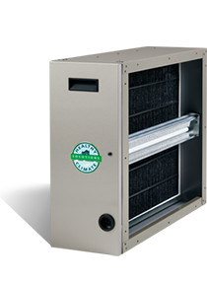
Best
The “BEST” solution for your home is an Electronic Air Cleaner. A Whole House Electronic Air Cleaner can remove up to 99.98% of unwanted airborne particles passing through the filter without significantly hampering your airflow. This type of Air Cleaner can trap particles as small as .1 microns in size. A cleaner reduces allergies and improves airflow!

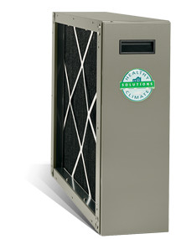Better
This Media Air Cleaner does not simply filter the air but cleans it as well. This air cleaner markedly increases filtration efficiency and dirt-holding capacity. It also has a very low pressure drop and requires little maintenance. This is the minimum you should consider.

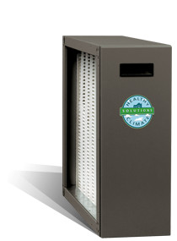
Good
This filter is traditionally used when there are space issues and no other filter will work. This filter must have 110 volts AC supply for power, but has very low 2-watt power usage. It also has low airflow resistance for the life of the media. Easy to maintain, this filter is an improvement over your standard 1” furnace filter.

Standard
The standard 1-inch furnace filter-the kind you replace monthly- simply doesn’t get the job done. These standard furnace filters are designed to protect the HVAC components…not you! These types of filter are only about 5-10% efficient and are even less efficient against potentially health-threatening particles which are 10 microns or smaller. Some retailers also offer ‘premium’ 1” deep filters with higher efficiency ratings. However, these filters can actually increase the pressure drop in the HVAC system, thereby decreasing your system’s performance. You can have our HVAC technician tell you exactly what kind of filters you’ll need to get the best out of your HVAC system, while providing the most effective air filtration possible.

