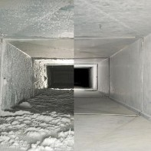
Duct Cleaning in Northern Virginia

Your home’s indoor air quality is important, which is why EDGE HVAC is proud to offer our customers high-quality duct cleaning services in Northern Virginia. Over time, it’s easy for dust and debris to accumulate in your home’s air ducts. As ducts become clogged, air no longer circulates as it should, which can cause heating and cooling problems. And dust and debris accumulation isn’t good for the air you breathe. When you’re in need of a duct cleaning specialist, call EDGE HVAC.
Superior Duct Cleaning Service
Do you have allergies or suffer from asthma? Clogged and contaminated duct work is not only hard on a home’s overall HVAC system; it’s also hard on your health. When dust, dirt and debris have nowhere else to go they are forced back into the air. A professional duct cleaning service can ensure that your ducts are cleaned correctly and remain free of hazardous buildup.
EDGE HVAC offers a comprehensive air duct cleaning service in Northern Virginia to ensure that your home has clean air. With the latest tools and equipment, our highly trained HVAC technicians thoroughly clean your ducts.
Do you need residential air duct cleaning in Virginia, D.C. or Maryland? Call EDGE HVAC at 571-225-1190 to schedule service today! EDGE HVAC proudly offers duct cleaning to Alexandria, Arlington, and Virginia, including the nearby communities of Culpeper, Fairfax, Fauquier, Loudoun, Prince William, Stafford.

