If you are in need of air conditioning repair in Virginia, contact the experts at EDGE HVAC. We’re family owned and operated and have been serving the Washington D.C. metro area for over 20 years.
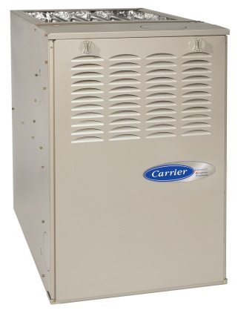
With our hot and humid summers, it’s important to have an air conditioning unit you can count on. Whether your unit has stopped working and is in need of immediate repair or you want to get a pre-season checkup to prevent a problem before it starts, our experts can help.
Our air conditioning (AC) repair service in Northern Virginia is first-rate. Our technicians will ensure that your unit will continue to run smoothly year after year. If you are shopping for a new unit, our experts can recommend and install a brand and model that will work best for your home and meet your cooling needs.
For those who want to ensure that their unit is in working order before the summer season begins – or at any other time – we proudly offer a precision tune up to troubleshoot any potential problems. Upon completion of the inspection, we will provide you with a comprehensive written report regarding your system’s status and make any recommendations necessary to improve your comfort level and head off any problems before they arise.
Please give us a call today at 571-225-1190 for first-class air conditioning service and repairs in the Northern Virginia.
We’re open seven days a week and provide 24/7 emergency service.

